## Why learning is more important to Employee Engagement than ever before!

Energising and optimising work in a COVID world!

**David Perring, September 2020**

It’s dangerous to make too many predictions in times of uncertainty, but in todays’ COVID world there are a few safe bets which I think we can all agree on.

## 1 Home working is here to stay

According to a [CIPD](https://www.cipd.co.uk/about/media/press/home-working-increases#:~:text=As%20the%20Government%20urges%20people,to%2018%25%20before%20the%20pandemic.) survey back in July, employers expect almost 40% of people to work regularly from home – after the pandemic has based. Practically doubling from pre COVID levels. Of those 1 in 5 are likely to work from home all the time. My guess is that the longer we go through local lock-downs and COVID surges – those numbers are going to increase – [especially 75-83% depending on the survey you review would who are currently working from home](https://www.skillcast.com/blog/working-from-home-survey-findings) would like to do so in the future – at least one day a week. And 20% wanting to work from home upto 3 days a week.

Interestingly the same [proportion of managers](https://yougov.co.uk/topics/economy/articles-reports/2020/09/03/quarter-bosses-become-work-home-converts) – 75% believe their people can work just as well at home..

Some major corporations are already rethinking their office strategy. For example Capita announced it planned to close over a third of offices permanently at end of August and other organisations like Lloyds Banking Group are reviewing their working practices and office space needs after concluding most of its 65,000 staff have worked effectively [from home during the crisis](https://www.bbc.co.uk/news/business-53968213?intlink_from_url=https://www.bbc.co.uk/news/business&link_location=live-reporting-story)

But whilst this maybe great for our carbon footprint, and remove the stress of the commute, it’s also coming at a cost to work life balance and our wellbeing. Half of managers fear [staff are burning](https://www.peoplemanagement.co.uk/news/articles/half-of-managers-fear-staff-are-burning-out-because-of-covid-19) out because of Covid-19.

What is clear that we still have a lot to learn about how to work sustainably from home, and how to maintain productivity in a remote workplace, especially as belts start to tighten and the survival pressures in many business – mean there are even few resources available and visibility of work volume and demands become less transparent.

Learning to create, work and manage a high-performance team in a virtual workplace is possibly one of the most important upgrades to our organisation of the past 6 months. And whilst we may have come to understand the tools of virtual working – mastering the teaming culture and understanding the interplay of teams and expectations and workflows is something we still need to do.

### Are we great at virtual / remote working today?

The truth is that most organisations have been incredibly responsive. Yes, we have adapted to the situation and grasped the new technology. Microsoft Teams **generated more than** [five billion meeting minutes](https://news.microsoft.com/en-gb/2020/09/08/for-remote-working-to-be-a-success-the-first-thing-we-need-to-change-is-how-we-think-about-it/)of meeting in a single day. But using the technology to connect does not simply mean we are being productive.

**A study by** [Boston Consulting Group](https://www.bcg.com/publications/2020/valuable-productivity-gains-covid-19) **published this August shows room for improvement 75% of employees said that they have been able to maintain or improve productivity on individual tasks. There are less distractions when we need to get our head down and get things done. But MODERN work isn’t only about your own tasks. Its about working together and getting more done because we are a team. And in that respect things aren’t so great.**

**When it comes to working together – 51% said they have been able to maintain or improve their productivity on collaborative tasks.**

**So, lots of us still have a lot to learn about how to work together and collaborate as a Virtual Team … And that is something we need to learn together. Learning to work as a virtual team is super important.**

**But this is not just about a short-term surge in productivity. It’s also about sustaining productivity. And the indicators are we are not doing as well as we should in that area too. It’s about having the resilience to keep delivering over the coming months and that is a bigger worry for us all. Especially as a second wave of lockdowns is hitting Europe.**

### **Where is virtual working failing?**

**The evidence would indicate that most of us are struggling to making virtual working work for us as individuals. The productivity surge from virtual working is coming at a cost to our people’s mental health. 62% in a recent** [Microsoft survey](https://news.microsoft.com/en-gb/2020/09/08/for-remote-working-to-be-a-success-the-first-thing-we-need-to-change-is-how-we-think-about-it/)felt less connected to their team working from home.

**In a mental health study by organisation TalkOut in September this year- over a third (35 per cent)** [reported](https://www.peoplemanagement.co.uk/news/articles/half-workers-received-no-covid-mental-health-support-poll-finds) **worse mental health now compared to before the pandemic.** A [staggering 75% of employees](ttps://hrexecutive.com/most-of-us-are-burned-out-what-more-can-hr-do-to-help/) say they’ve faced burnout at work, With 40% saying they’ve experienced burnout during the pandemic specifically..”

Again there is a clear gap in virtual working capability, support and mindset which many organisations still need to bridge. WE need to LEARN as individuals, teams and organisations to create a more sustainable relationship to delivering results and building our virtual company culture.

Now, the foundations of Wellbeing are well established. The mental health charity [MIND](https://www.mind.org.uk/workplace/mental-health-at-work/taking-care-of-yourself/five-ways-to-wellbeing/) highlights the 5 ways to wellbeing - ***Give, Keep Learning, Be active, Take Notice, Connect.*** In many ways there are a charter for all organisations to make virtual working more successful. But turning them from being words into behaviours needs to be learning and coaching and support in how we work. And in that respect LEARNING is and will be essential in driving sustainable success in the future.

And lets be clear. That’s learning not just from courses, resources and coaching, but also through knowledge peer to peer sharing, trust building, relationships, our connections and feedback. The human touch of working as a team which is too easily ignored when we only transition working practices and not connecting and social behaviours into the virtual workplace. This is not about the technology but the human touch, and culture we all need to thrive as a virtual team.

## Off boarding, re-boarding and good farewells matter

As if the last 6 months haven’t already, many of us are in for some tough times ahead.

The pressures of changing consumer behaviour, economic stress and uncertainty is going to mean organisations restructuring and losing people - As furlough ends for some, offboarding is inevitable for many industries at the sharp end of COVID economics.

This means parting on good terms both for the benefits of our consumer brand, those who remain and in the hope that good people will re-join us when the Post COVID boom hits. With the economic shock expected to last [between 1 to 2 years](https://www.reuters.com/article/us-global-economy-poll-idUSKCN24W01B) – all organisations need to take some very careful choices

### Now is ***not*** the time to trash your employer brand

The point is your employer brand could take an absolute irrecoverable hammering if you do not do this well – because the people you keep will also be judging you by what you do to others less fortunate today.

Not only does poor treatment disengage the survivors it may well trigger them to look elsewhere for more secure employment. And make no bones about it – if people decide to leave in a competitive candidate market, the ones who choose to leave and get jobs elsewhere will be the absolute cream of the crop!

So, farewells, offboarding matters for engagement – and looking at the training and development you support people who are leaving you is one way build your employer brand and reputation for being a great employer. Remember that learning and personal growth was the NO 1 driver for job seekers to join a new organisation prior to the pandemic! (LINK TO SKILLS RESEARCH from 2019- BRIDGE)

### It’s time to build an infectious reputation to retain top talent and the best new talent and accelerate growth

Equally doing a great job of reboarding and re-orienteering people into the work into the workplace be that home, retail, manufacturing etc also is a lever on engagement and performance.

At the root of Re-boarding is training, learning resources and coaching – so that your people can optimise what they do as fast as possible. Be that a shift on roles and understanding new processes, procedures, products or regulatory environments.

Many of the predictable drivers from training and learning are here en-masse for those who are reboarding into roles that are new them or that have shifted.

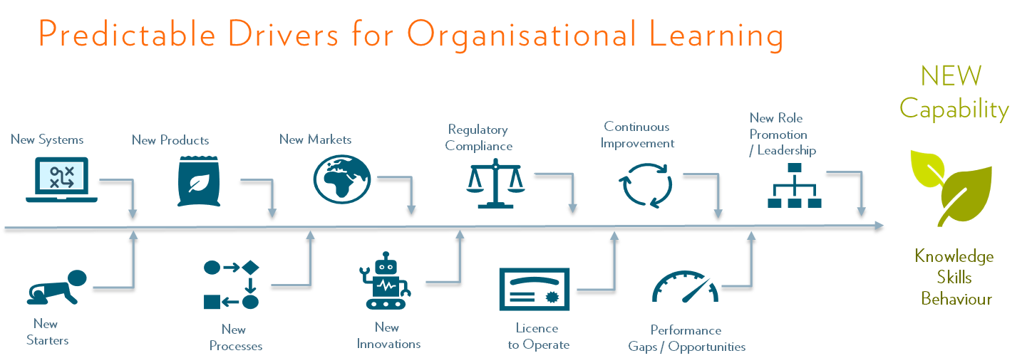

Doing re-boarding brilliantly is a sure fire way to build engagement and strengthen the belief that your organisation is worthy of workers commitment because you are a competent and caring organisation.

[Research](https://www.glintinc.com/blog/why-learning-is-essential-to-employee-engagement/) has shown that, compared to their peers, employees who see good opportunities to learn and grow at their organisation are 3.6 times more likely to report being happy.

## 3 Upskilling and Reskilling is the difference between success and failure

At the end of the day - in this harsh environment we have a responsibility to do three things - optimise how work happens, energise people to do great work and use the intelligence about our people, outcomes and customers to drive better decisions about how to work to deliver for our customers.

When the world of work changes so fundamentally, how work is organised, how we function as teams, how we create a culture high performance virtual teams and teaming, how we engage with new customer behaviours, new markets and products – that requires a whole shift in the skills of our people.

Leave people to struggle on their own, without community, connection, purpose, the tools for building resilience, expertise or skills to navigate that tumult of change and you are asking for trouble. Your abandonment of them will mean they leave you.

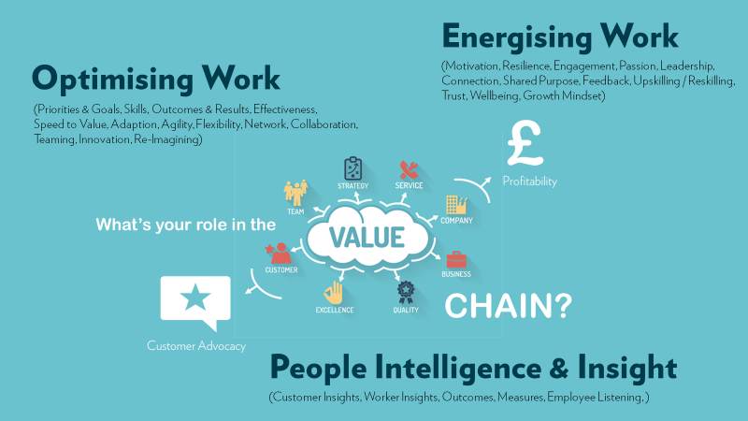

*Copyright Fosway Group. All Rights Reserved.*

### Skills are the vaccine for surviving ***your*** new normal

It’s skills – upskilling and reskilling that enables us to reimagine, innovate and execute so we can be more effective and drive better value for each other, for ourselves and our customers.

It’s the new skills we have in leading virtual projects, working as teams in remote ways, and shaping products and solutions that fit our customers with flexibility and agility

It’s the skill of reframing, problem solving and using situations to use them to build our energy and mastery to dissipate stress and build motivation and engagement. But there is more to this than skills and upskilling.

## 4 But, the most important thing we need to learn is what makes people love working here, when we are increasingly apart

The most important LEARNING WE ALL NEED TO DO is about what really makes us” love working here!”

If we are to thrive in 2021, possibly the most important conversations we need to have is about what needs to change in how we work, how collaborate, connect and support each other to make working better and more effective. .

How we empower teams to bridge the gaps where we don’t love working here or build on the positives is possibly the biggest learning challenge, we all have.

It means being a true LEARNING ORGANISATION and using employee listening as the catalyst for how we make work better around here. And this is the most critical learning of all. It’s our gateway to reimagine work, redefine our virtual working relationships and sustainably energise our people to out-perform. – not matter where they are.