Make better HR, talent and learning buying decisions faster

**HR Transformation, Digital HR, Cloud HCM, Talent Management, Talent Acquisition, Recruiting and Onboarding, Performance, Employee Experience, Learning Transformation, Digital Learning, LMS, Next Gen Learning Environments, Learning Experience Platforms, Digital Learning, …**

With a rapidly changing workplace, workforce, supplier options and competition for talent, the world of HR and talent is increasingly challenging. Companies are under more pressure than ever to reinvent their HR, talent and learning processes to be more agile, more digital and to deliver more value and impact to the business. The pressure to invest in new solutions continues to grow, as does the cost and consequences of those investments. Making sure you invest wisely, with the best chances of success is more critical than ever.

Are your grappling with:

* *Too much to get done and too little time or expert resources to truly make the best decisions?*
* *Too many stakeholders with too many conflicting priorities?*
* *Too many vendor options and not enough real insight what they really do and what differentiates them?*
* *Too many people with a vested interest in influencing your choices to suit their agenda?*

That’s where Fosway comes in. As Europe’s #1 HR Industry Analyst, we are completely independent and have unique corporate insight, vendor research, and a proven methodology to help you make the right buying decisions faster.

UNIQUELY INDEPENDENT

With over 20 years of providing independent analyst input to enterprise clients, Fosway has significant expertise in working with large multi-national organisations and helping them making the right buying decisions. As well as accessing the best existing European research and market insight, you also have the security of knowing that we are completely independent and don’t have a vested interest in your end decision, beyond the quality of the decision itself.

***Why start your procurement process from scratch when we already have the research and insight to help you make better supplier decisions much faster?***

OUR METHODOLOGY:

Referencing our Fosway 9-Grids™ is a great place to start when evaluating current suppliers or looking for new tools and technology. But what the 9-Grids™ are just the tip of the iceberg. As well as access to data behind the 9-Grid™, Fosway also has developed tools and a methodology to help companies make better HR buying decisions faster.

Our unique 3 step model is proven to support key supplier decisions, regardless of your starting point. From ensuring stakeholder and strategy alignment, to validating your business case and framework to act, through to accelerating vendor engagement, selection and procurement.

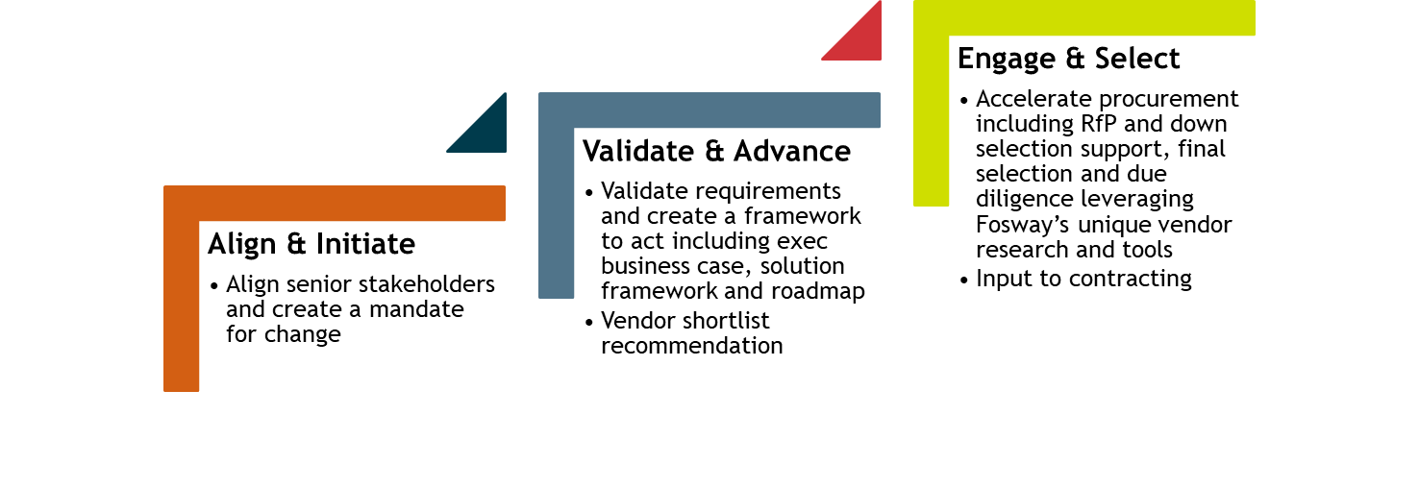

*Copyright Fosway Group Limited. All rights reserved.*

Whether you start from **Align & Initiate** or **Validate & Advance** or are ready to go straight into **Engage & Select**, Fosway can bring the best research, the best vendor insight, and the best decision tools to accelerate your decision making and success.

Our methodology aims to rapidly identify the scope, sophistication and flexibility you need as well as any differentiating functionality or requirements. This ability to differentiate between “business as usual” and truly unique/differentiated needs is important to understanding the real fit to your organisation. And in complex organisations with many stakeholders and conflicting priorities, it is paramount.

ENGAGING WITH FOSWAY

Whether you are engaging with us through our accelerated decision model, or just looking for an independent sounding board to review options, all corporate activities are contracted through our corporate engagement programme, providing the flexibility and the security of having an expert critical friend on tap to support your key decisions when you most need it.

***Talk to us today about engaging with Fosway to help you make better HR buying decisions faster!***

* *Deep expertise of Next Gen HR, talent and learning in leading European and International companies with over 22 years of research and insight*
* *Unique Fosway 9-Grid™ vendor analysis supported by data and decision tools built from up to date independent corporate and vendor research*
* *Complete objectivity, integrity and lack of vested interest*
* *A flexible working approach designed to accelerate decision making and client success*